**Name: Zohair Tahir**

**Section: CS-B**

**Date: 21/6/20**

**Case Study 1.**

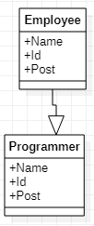

class Employee:

def __init__(self,name,id,post):

self.name = name

self.id = id

self.post = post

class Programmer(Employee):

def __init__(self,name,id,post):

Employee.__init__(self,name,id,post)

print('The name of the employee is {} his employee id is {} and his post in the office is {}'.format(self.name,self.id,self.post))

obj=Programmer('Fahad','714','manager')

**Case Study 2.**

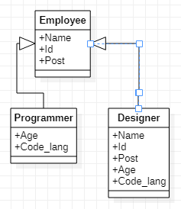

class Employee:

def __init__(self,name,id,post):

self.name = name

self.id = id

self.post = post

print('The name of the employee is {} his id is {} and his post is {}'.format(self.name,self.id,self.post))

class Programmer:

def __init__(self,age,code_lang):

self.age = age

self.code_lang = code_lang

print('The age of the programmer is {} and he has the experience to code on {} languarge'.format(self.age,self.code_lang))

class Designer(Employee,Programmer):

def __init__(self,name,id,post,age,code_lang):

Employee.__init__(self,name,id,post)

Programmer.__init__(self,age,code_lang)

print('The designer name is {} and his age is {}'.format(self.name,self.age))

obj1=Designer('Ali','176','manager',17,'c++')

**Case Study 3.**

**UML Diagram:**

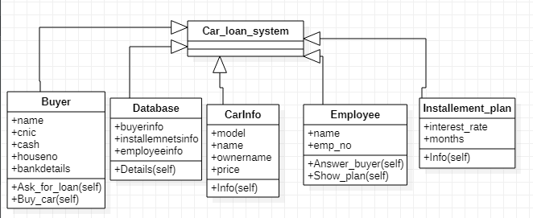**Sequence Diagram:**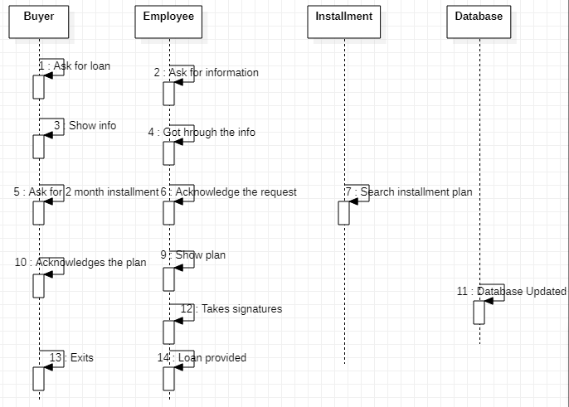

**Activity Diagram:**

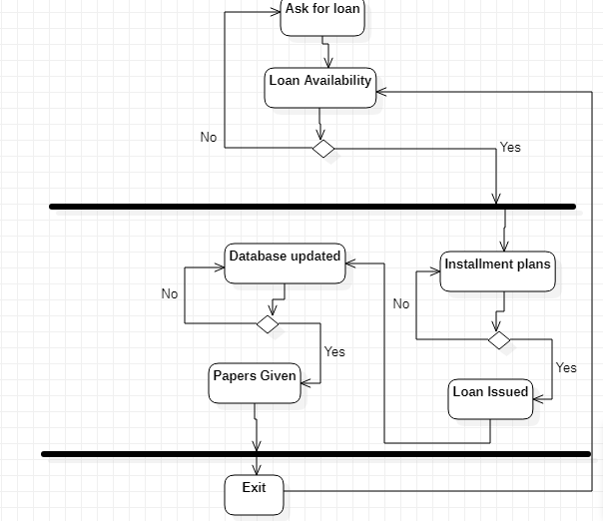

#!/usr/bin/python

#-*- coding: utf-8 -*-

class Car_loan_system:

print('The loan system has the following attributes')

class Buyer(Car_loan_system):

def __init__(self,name,cnic,cash,houseno,bankdetails):

self.name = name

self.cnic = cnic

self.cash = cash

self.houseno = houseno

self.bankdetails = bankdetails

def Ask_for_loan(self):

print('My name is {} his cinic is {} his house number is {} and his bank details are {}'.format(self.name,self.cnic,self.houseno,self.bankdetails))

def Buy_car(self):

print('The price of the car is {}'.format(self.cash))

class CarInfo(Car_loan_system):

def __init__(self,model,name,ownername,price):

self.model = model

self.name = name

self.ownername = ownername

self.price = price

def Info(self):

print('The name of the car is {} the model of the car is {} and the price of the car is {}'.format(self.name,self.model,self.price))

class Database(Car_loan_system):

def __init__(self,buyerinfo,installmentinfo,employeeinfo):

self.buyerinfo = buyerinfo

self.installemnetsinfo = installmentinfo

self.employeeinfo = employeeinfo

def Details(self):

print('The buyer information is {} and the installment information is {}'.format(self.buyerinfo,self.installemnetsinfo))

class Employee(Car_loan_system):

def __init__(self,name,emp_no):

self.name = name

self.emp_no = emp_no

def Answer_buyer(self):

print('The name of employee is {} and his employee number is {}'.format(self.name,self.emp_no))

def Show_plan(self):

print('The plan information is here')

class Installement_plan(Car_loan_system):

def __init__(self,interest_rate,months):

self.interest_rate = interest_rate

self.months = months

def Info(self):

print('The installment form has a interest rate of {} and the insatllment consist of {} months'.format(self.interest_rate,self.months))

obj=Buyer('Zohair','6456734',798758,'789','meezan bank')

obj.Ask_for_loan()

obj.Buy_car()

obj1=CarInfo('2006','civic','Zohair','89798')

obj1.Info()

obj2=Database('Zohair',2,'Fahad')

obj2.Details()

obj3=Employee('Fahad',878)

obj3.Show_plan()

obj4=Installement_plan('20%',4)

obj4.Info()

**Case Study 4:**

**UML:**

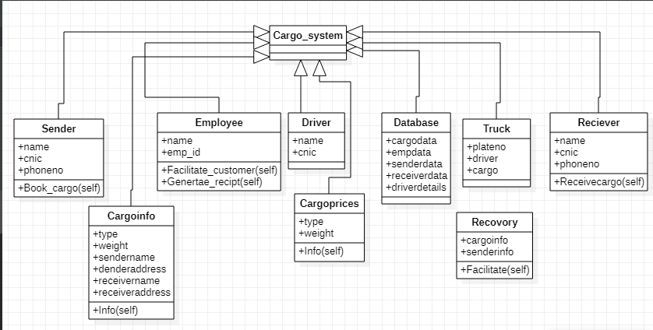

**Sequence:**

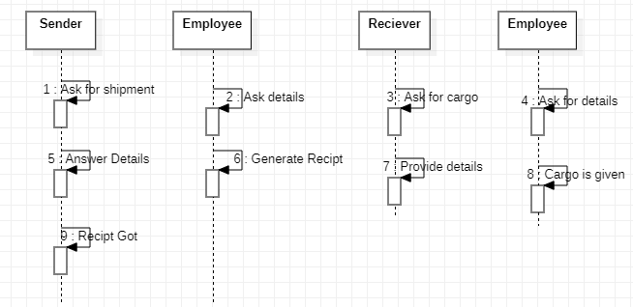

**Activity Diagram:**

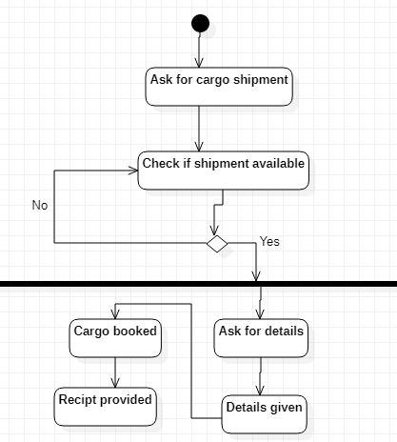

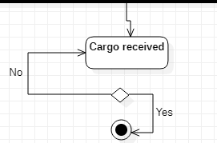

**Coding:**

class Cargo_system:

print('This is a cargo system designed with some important aspects of a cargo system')

class Sender:

def __init__(self,name1,cnic,phoneno):

self.name1 = name1

self.cnic = cnic

self.phoneno = phoneno

def Book_cargo(self):

print('The name of sender is {} his cnic is {} and his phone no is {}'.format(self.name1,self.cnic,self.phoneno))

class Employee(Sender):

def __init__(self,cnic,name1,phoneno,name,emp_id,):

self.name = name

self.emp_id = emp_id

Sender.__init__(self,name1,cnic,phoneno)

#self.cnic = cnic

#self.name1 = name1

#self.phoneno = phoneno

def Facilitate_customer(self):

print('The name of employee is {} his emp id is {}'.format(self.name,self.emp_id))

def Generate_recipt(self):

print('The sender name is {} his phone number is {} while the employee name is {}'.format(self.name1,self.cnic,self.name))

class Cargoinfo(Cargo_system):

def __init__(self,type,weight,sendername,senderaddress,recievername,recieveraddress):

self.type = type

self.weight = weight

self.sendername = sendername

self.senderaddress = senderaddress

self.receivername = recievername

self.receiveraddress = recieveraddress

def Info(self):

print('The type of cargo is {} its weight is {} the sender name is zohair'.format(self.type,self.weight))

class Cargoprices(Cargo_system):

def __init__(self,weight,price):

self.weight = weight

self.price = price

def Info(self):

print('The price for {} kg of package is {}'.format(self.weight,self.price))

class Database(Cargo_system):

def __init__(self,cargodata,empdata,senderdata,receiverdata,driverdetails):

self.cargodata = cargodata

self.empdata = empdata

self.senderdata = senderdata

self.receiverdata = receiverdata

self.driverdetails = driverdetails

def Info1(self):

print('The cargo data is {} the emp data is {},the sender data is {} and the receiver data is {}'.format(self.cargodata,self.empdata,self.senderdata,self.receiverdata))

class Driver(Cargo_system):

def __init__(self,name,cnic):

self.name = name

self.cnic = cnic

def Info2(self):

print('The name of driver is {} and his cnic is {}'.format(self.name,self.cnic))

class Truck(Cargo_system):

def __init__(self,plateno,driver,cargo):

self.plateno = plateno

self.driver = driver

self.cargo = cargo

def Info3(self):

print('The plate number of truck is {} and the driver name is {}'.format(self.plateno,self.driver))

class Recovery:

def __init__(self,cargoinfo,senderinfo):

self.cargoinfo = cargoinfo

self.senderinfo = senderinfo

def Facilitate(self):

print('The cargo information is {} and name of sender is {}'.format(self.cargoinfo,self.senderinfo))

class Reciever(Cargo_system):

def __init__(self,name,cnic,phoneno):

self.name = name

self.cnic = cnic

self.phoneno = phoneno

def Receivecargo(self):

print('The name of receiver is {} his cnic is {}'.format(self.name,self.cnic))

obj1=Employee('fahad','8787','76869976','Zohair','0213490')

obj1.Facilitate_customer()

obj1.Generate_recipt()

obj4=Cargoinfo('Packed','26kg','Zohair','phase-1','Humayun','phase-1')

obj4.Info()

obj5=Cargoprices('26kg','RS.655')

obj5.Info()

obj6=Database('3 packs','Fahad','Zohair','Humayun','Ali Baksh')

obj6.Info1()

obj7=Driver('Ali Baksh','98059')

obj7.Info2()

obj8=Truck('JF-9076','Ali Baksh','Packets')

obj8.Info3()

obj9=Recovery('Packets','Zohair')

obj9.Facilitate()

obj10=Reciever('Humayun','89798','033499029')

obj10.Receivecargo()